**2.4 I can use and apply industry standard testing regimes and (describe) project management techniques**

As an extension of the Waterfall model, the *V model* is a popular testing regime for the development of software.

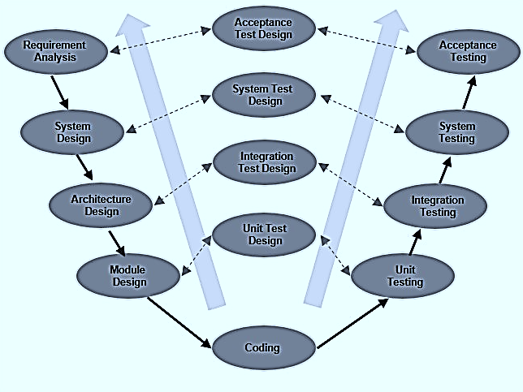

Above image originally taken from <https://www.tutorialspoint.com/sdlc/sdlc_v_model.htm>.

As can be seen from the above diagram, at each stage of software development, test designs are created. Once the development reaches the coding stage, tests are then performed, using the designs, on how well it meets the expectation of each stage. Analysis of requirements (stage 1) and the testing of whether the requirements are met can often take the longest, as a customer may not be sure of what they want or might change their mind throughout the process.

For this latter reason, the V model is not as useful for long projects or indecisive customers. It is however simple to understand and follow and it works well for small projects with decisive stakeholders.

**Agile methodology**